**CMS: Adding and Versioning Landing Pages.**(Using windstreamauthorizeddeals.com as a model)

By David Morgan   
November 20, 2014

**Contents**

1. Description
2. Versioning
3. Adding Include Files
4. Navigation
5. State Links
6. City Data
7. **Description**

The following is the instructional guide to adding a new set of landing pages into CMS and versioning them on to the marketing servers. The pages include city and state navigation for search optimization along with city data. These are additional include files that read XML files built from CMS and display onto the landing pages.

This is an example site structure as it resides on the server (windstreamauthorizeddeals.com):  
**Example File Structure:**

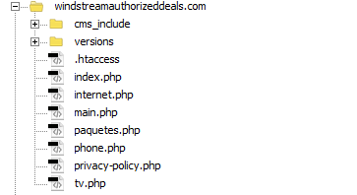

The php files displayed are the standard for versioning and main.php being a configuration file for the entire versioned pages and connection to CMS. Inside the php files is the siteid which is configured inside the CMS. These must match. The php content also has a pointer to each corresponding HTML file inside each versioned set of landing pages. Example, index.php:

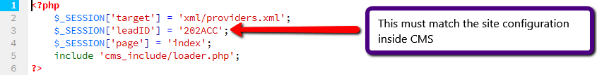

Inside the versions directory resides each version and within each version reside the HTML files and page assets as shown below:  
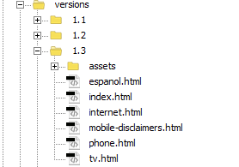

Inside the cms_include directory reside all the include files which must be attached or plugged into each HTML page. Directory structure shown below:

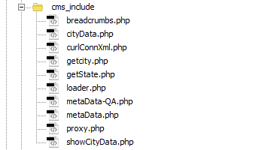

1. **Versioning**

**The first step in creating a new version** is to create a new numeric directory with in the versions directory. Example, if the last version is 1.3 the next version would be 1.4 and so on.

Inside the new version you will add the new HTML files and page assets.

You will need to edit each HTML file and thus plug in the include files.

1. **Adding Include Files  
     
   Starting with the top of the HTML file or the Head** you will add the following include files (example snippet from HTML file):

<?php include "cms_include/curlConnXml.php"; ?>  
<!DOCTYPE HTML>  
<html>  
<head>  
<meta charset="utf-8">  
<?php include "cms_include/metaData.php"; ?>  
<meta http-equiv="X-UA-Compatible" content="IE=edge">  
<meta name="viewport" content="width=device-width, initial-scale=1.0">

The include filenames are descriptive of the will display in that area of HTML.  
The first being a connection string to the City State XML – **curlConnXml.php**This include file does NOT display any dataThe second, **metaData.php** handles meta tags including site title.   
**NOTE:** If the following HTML meta tags are in place, “ TITLE, META CONTENT-DESCRIPTION, META CONTENT-KEYWORD”, remove them and replace with the include file.

The next set of edits will be versioning the assets.  
all asset src files will need to be replaced as shown below:

**Original**<link href=" assets/css/bootstrap.css" rel="stylesheet">

**Updated**<link href="/versions/<?php echo $pathVersion; ?>/assets/css/bootstrap.css" rel="stylesheet">

This includes ALL **CSS, JS**, and **IMG** assets.

After the opening body tag, where ever you would like to display breadcrumbs you can include the breadcrumbs include:  
<?php include ("cms_include/breadcrumbs.php"); ?>

1. **Navigation**

The navigation of pages via anchor tag is not an include but rather a place holder that renders from the main.php or configuration file. They are appropriately named for ease of implementation. Below is an example of navigation:

<ul class="nav navbar-nav">  
<li class="active"><a href="<?php echo $navBundles; ?>">Bundles</a></li>  
<li><a href="<?php echo $navTv; ?>">TV</a></li>  
<li><a href="<?php echo $navInternet; ?>">Internet</a></li>  
<li><a href="<?php echo $navPhone; ?>">Digital Phone</a></li>  
<li class="last"><a href="<?php echo $navPaquetes; ?>">Espanol</a></li>  
 </ul>

1. **States Links**

The following include file displays the footprint via links to each state with in that footprint.  
This reads from the XML file and is controlled by CMS. This can be placed, usually near the bottom of the page before the footer. It may be placed anywhere within the HTML page.

<!--GET STATES-->  
<?php include ('cms_include/getState.php'); ?>  
<!--GET STATES-->

1. **City Data**

The city data include file can be placed below the state links. This reads the CityData XML controlled from CMS and displays pertinent data from the city selected via city navigation:

<!--City Data-->  
<?php include ('cms_include/cityData.php'); ?>  
<!--City Data-->